
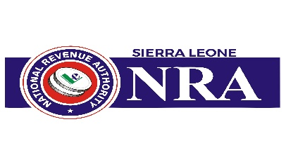
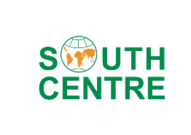
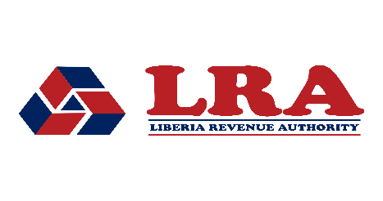

JOINT OFFICIAL ANNOUNCEMENT

ECOWAS-Led Simultaneous Tax Audit
Republic of Liberia & Republic of Sierra Leone
A Regional Tax Cooperation Initiative Under the ECOWAS Framework

Issuing Authority | ECOWAS Commission — Customs Union & Taxation Directorate
Participating States | Republic of Liberia | Republic of Sierra Leone
Technical Partner | South Centre, Geneva
Legal Basis | ECOWAS Supplementary Act on Mutual Administrative Assistance in Tax Matters
Initiative Type | Pilot Simultaneous Tax Audit (STA)
Date of Announcement | April 2026

1. BACKGROUND AND CONTEXT
West Africa's integration agenda requires not only the free movement of goods and persons, but equally the integrity of member states' fiscal systems. Tax avoidance and evasion by multinational enterprises operating across the ECOWAS region deprive governments of vital revenues needed to finance public services, infrastructure, and sustainable development.
In response to this shared challenge, the Economic Community of West African States (ECOWAS), www.ecowas.int has established a comprehensive legal architecture for regional tax cooperation. Central to this architecture is the ECOWAS Supplementary Act on Mutual Administrative Assistance in Tax Matters, https://ecowas.int/publication/regional-tax-directives/ which authorizes member states to conduct joint and simultaneous audits of taxpayers with cross-border operations, and to share information necessary for the accurate determination of tax liabilities.
Building on this framework, the ECOWAS Commission's Customs Union and Taxation Directorate has initiated a Simultaneous Tax Audit (STA) pilot program, beginning with a bilateral exercise jointly conducted by the Liberia Revenue Authority (LRA) and the National Revenue Authority of Sierra Leone (NRA). This pilot is designed to serve as a model for broader regional deployment.
2. ABOUT THE SIMULTANEOUS TAX EXAMINATION
A Simultaneous Tax Examination (STE) is an internationally recognised instrument of tax administration under which two or more tax authorities independently, but simultaneously and in a coordinated manner, examine the tax affairs of taxpayers of common or related interest. The objective is to detect and counteract cross-border tax avoidance, transfer pricing abuse, and artificial profit-shifting arrangements that cannot be effectively addressed by a single tax administration acting alone. STEs are also proven to be very effective in preventing disputes, thus enhancing tax certainty, reducing risks of double taxation, increasing investor confidence and boosting cross-border trade and investment flows.

The ECOWAS-led pilot STE between Liberia and Sierra Leone, which will be a pioneering exercise in the whole of the Global South, will focus on enterprises with substantial operations in both jurisdictions. The audit will be conducted in strict accordance with applicable domestic law and the ECOWAS Supplementary Act, with results and findings exchanged through established channels of competent authority cooperation.
Key features of the pilot include:
- Coordinated selection of audit cases based on risk profiles shared between the LRA and NRA.
- Parallel, independent audit proceedings conducted by each tax authority within its own territory and legal framework.
- Structured information exchange on audit findings, as provided under the ECOWAS Supplementary Act on Mutual Administrative Assistance.
- Joint review sessions to align observations on intercompany transactions, profit allocation, and tax positions.
- A post-audit evaluation to document impact and lessons learned for wider regional replication.
3. LEGAL FRAMEWORK
The STE pilot derives its authority from the ECOWAS Supplementary Act on Mutual Administrative Assistance in Tax Matters, which provides a binding regional legal basis for:
- Exchange of information between member state tax authorities upon request, spontaneously, or automatically;
- Simultaneous tax examinations and joint tax audits involving taxpayers subject to the jurisdiction of two or more member states; and
- Assistance in tax collection and service of documents across borders.
4. ROLE OF THE SOUTH CENTRE
The South Centre, an intergovernmental organization of developing countries headquartered in Geneva, Switzerland, and including Liberia and Sierra Leone among its Member States, is providing dedicated technical support to this initiative. The South Centre's Tax Initiative has extensive expertise and capacity to support developing country tax administrations in the design and conduct of transfer pricing audits, international tax cooperation mechanisms, and capacity building.
In the context of this STA pilot, the South Centre will provide:
- Technical guidance on the design and methodology of the simultaneous audit process;
- Capacity-building support for audit teams of the LRA and NRA, including on transfer pricing analysis and the application of the arm's length principle;
- Facilitation of coordination between the two participating tax authorities throughout the audit cycle; and
- Documentation of best practices, outcomes, and recommendations for the replication of the STA model across the ECOWAS region.
The ECOWAS Commission warmly acknowledges the South Centre's commitment to strengthening tax governance in its member states and expresses its appreciation for this strategic partnership.
5. SIGNIFICANCE FOR THE ECOWAS REGION
This initiative marks a pivotal step in the ECOWAS Commission's efforts to build an integrated and effective tax administration architecture for its member states. By coordinating audit efforts across borders, member states send a clear signal to multinationals that profit-shifting schemes exploiting ECOWAS integration will be identified and addressed.

The Liberia–Sierra Leone STA pilot will:
- Generate practical experience and institutional capacity in simultaneous audit conduct within the ECOWAS framework;
- Demonstrate the operationalization of the ECOWAS Supplementary Act on Mutual Administrative Assistance, thereby strengthening the normative credibility of the regional legal framework;
- Contribute to enhanced domestic revenue mobilization in both Liberia and Sierra Leone, supporting the Sustainable Development Goals (SDGs) and the ECOWAS Agenda 2050, https://www.ecowas.int/wp-content/uploads/2022/09/Vision-2050-EN.pdf; and
- Serve as a replicable model for future multilateral and bilateral STA exercises among other ECOWAS member states.
The Commission envisions this pilot as the first in a series of systematic STA exercises that will progressively cover all twelve ECOWAS member states, ultimately establishing a standing regional simultaneous and joint audit program as a permanent pillar of ECOWAS tax cooperation.
6. COMMITMENT OF PARTICIPATING AUTHORITIES
The Liberia Revenue Authority (LRA) and the National Revenue Authority of Sierra Leone (NRA) reaffirm their commitment to regional tax cooperation as a cornerstone of effective domestic revenue administration. Both authorities have designated Competent Authority representatives and dedicated audit teams for this initiative and are fully engaged in the coordination process facilitated by the ECOWAS Commission and the South Centre.
Both tax administrations are committed to conducting the audit in a professional, fair, and taxpayer-respectful manner, consistent with their respective domestic legislation and the rights and obligations enshrined in the ECOWAS Supplementary Act.
The renewed commitment highlights growing efforts among ECOWAS countries to deepen cooperation in tax administration as part of broader strategies to strengthen economic governance and regional integration.

Issued jointly by:
ECOWAS Commission  Customs Union & Taxation Directorate  Abuja, Nigeria  ________________________ | Liberia Revenue Authority (LRA)  Commissioner General  Monrovia, Liberia  ________________________ | National Revenue Authority (NRA)  Commissioner General  Freetown, Sierra Leone  ________________________

Technical Support Partner: South Centre, Geneva, Switzerland

For enquiries, contact the ECOWAS Commission Customs Union & Taxation Directorate, info@ecowas.int or the Competent Authority of the Liberia Revenue Authority, info@lra.gov.lr or National Revenue Authority of Sierra Leone. Info@nra.gov.sl
This announcement is published simultaneously on the official websites of the Liberia Revenue Authority, the National Revenue Authority of Sierra Leone, and the South Centre.

